

NATIONAL INSTITUTE OF TECHNOLOGY KARNATAKA

SURATHKAL, MANGALORE - 575 025

Course Code – CS254

Course Name – Database Systems Lab

Lab - 02

Date – February 2, 2022

Submitted To

Dr. Annappa B

Department of Computer Science and Engineering

National Institute of Technology Karnataka, Surathkal

Submitted By

Md Rakib Hasan

Roll – 201CS132

Department of Computer Science and Engineering

**2. Build a Department database which consist of following information:**

**Student (Rollno, Name, Dob, Gender, Doa, Bcode);**

**Branch (Bcode, Bname, Dno);**

**Department (Dno, Dname);**

**Course (Ccode, Cname, Credits, Dno);**

**Branch_Course (Bcode, Ccode, Semester);**

**Enrolls (Rollno, Ccode, Grade);**

**Write Queries for the following:**

CREATE DATABASE IF NOT EXISTS department_info;

USE department_info;

CREATE TABLE department (

    d_no VARCHAR(5) NOT NULL,

    d_name VARCHAR(50),

    PRIMARY KEY (d_no));

CREATE TABLE branch (

    b_code VARCHAR(5) NOT NULL,

    b_name VARCHAR(50),

    d_no VARCHAR(5) NOT NULL,

    PRIMARY KEY (b_code),

    FOREIGN KEY (d_no) REFERENCES department(d_no));

CREATE TABLE course (

    c_code VARCHAR(5) NOT NULL,

    c_name VARCHAR(50),

    credits INT,

    d_no VARCHAR(5) NOT NULL,

    PRIMARY KEY (c_code),

    FOREIGN KEY (d_no) REFERENCES department(d_no));

CREATE TABLE student (

    rollno INT NOT NULL,

    name VARCHAR(50),

    dob DATE,

    gender CHAR(1),

    doa DATE,

    b_code VARCHAR(5) NOT NULL,

    PRIMARY KEY (rollno),

    FOREIGN KEY (b_code) REFERENCES branch(b_code)

    );

CREATE TABLE branch_course (

    b_code VARCHAR(5) NOT NULL,

    c_code VARCHAR(5) NOT NULL,

    semester INT,

    FOREIGN KEY (b_code) REFERENCES branch(b_code),

    FOREIGN KEY (c_code) REFERENCES course(c_code));

CREATE TABLE enrolls (

    rollno INT NOT NULL,

    c_code VARCHAR(5) NOT NULL,

    grade INT,

    FOREIGN KEY (rollno) REFERENCES student(rollno),

    FOREIGN KEY (c_code) REFERENCES course(c_code));

INSERT INTO department

    VALUES ("D1", "CSE"),

    ("D2", "EEE"),

    ("D3", "IT"),

    ("D4", "ME"),

    ("D5", "IPE");

INSERT INTO branch

    VALUES ("B1", "B1_CSE", "D1"),

    ("B2", "B2_CSE", "D1"),

    ("B3", "B1_EEE", "D2"),

    ("B4", "B2_EEE", "D2"),

    ("B5", "B1_IT", "D3"),

    ("B6", "B2_IT", "D3"),

    ("B7", "B1_ME", "D4"),

    ("B8", "B1_IPE", "D5");

INSERT INTO course

    VALUES ("C1", "C1_CSE", 4, "D1"),

    ("C2", "C2_CSE", 4, "D1"),

    ("C3", "C1_EEE", 2, "D2"),

    ("C4", "C1_EEE", 3, "D2"),

    ("C5", "C1_IT", 4, "D3"),

    ("C6", "C1_IT", 4, "D3"),

    ("C7", "C1_ME", 1, "D4"),

    ("C8", "C1_IPE", 4, "D5");

INSERT INTO student

    VALUES (1, "S1", "2001-01-01", "M", "2005-01-01", "B1"),

    (2, "S2", "2000-01-01", "M", "2005-01-02", "B2"),

    (3, "S3", "2001-02-01", "F", "2005-01-01", "B3"),

    (4, "S4", "2001-03-01", "M", "2005-01-05", "B4"),

    (5, "S5", "2001-07-01", "M", "2005-01-01", "B5"),

    (6, "S6", "2001-02-05", "F", "2005-01-04", "B6"),

    (7, "S7", "2001-01-20", "M", "2005-01-06", "B7"),

    (8, "S8", "2001-05-01", "F", "2005-01-07", "B8"),

    (9, "S9", "2001-01-01", "M", "2005-01-01", "B1"),

    (10, "S10", "2001-02-01", "M", "2005-02-01", "B2"),

    (11, "S11", "2001-03-01", "F", "2005-01-11", "B3"),

    (12, "S12", "2001-04-01", "M", "2005-01-14", "B4"),

    (13, "S13", "2001-05-01", "M", "2005-01-13", "B5");

INSERT INTO branch_course

    VALUES ("B1", "C2", 1),

    ("B2", "C2", 2),

    ("B3", "C3", 3),

    ("B4", "C4", 4),

    ("B5", "C5", 5),

    ("B6", "C6", 6),

    ("B7", "C7", 7),

    ("B8", "C8", 1),

    ("B2", "C1", 1),

    ("B2", "C8", 2),

    ("B3", "C4", 3),

    ("B1", "C4", 4),

    ("B5", "C6", 5),

    ("B6", "C5", 6),

    ("B8", "C7", 1),

    ("B7", "C8", 8);

INSERT INTO enrolls

    VALUES (1, "C1", 4),

    (2, "C2", 4),

    (3, "C3", 4),

    (4, "C4", 5),

    (5, "C5", 4),

    (6, "C6", 6),

    (7, "C7", 4),

    (8, "C8", 5),

    (9, "C1", 8),

    (10, "C2", 9),

    (11, "C3", 4),

    (12, "C4", 7),

    (13, "C5", 6);

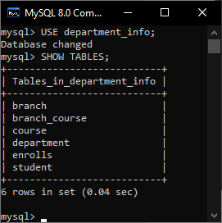

**a. Print the details of students who are from the same department.**

SELECT s.rollno,

        s.name,

        s.dob,

        s.gender,

        s.doa,

        d.d_name

FROM student s

JOIN branch b

    USING (b_code)

JOIN department d

    USING (d_no)

WHERE b_code IN (

    SELECT b_code

    FROM branch

    WHERE d_no = "D1")

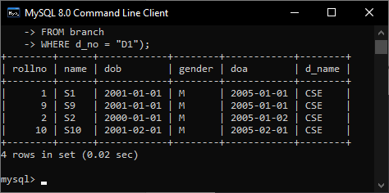

**b. Get the details of branches under a particular Department;**

SELECT d.d_no as DEPT_ID,

        d.d_name as DEPT,

        b.b_code as BRANCH_CODE,

        b.b_name as BRANCH

FROM department d

JOIN branch b

    USING (d_no)

WHERE d_name = "CSE"

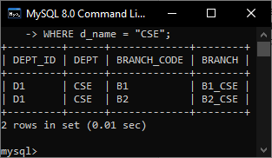

**c. Print the names of courses offered in a particular department in a particular semester;**

SELECT c.c_name, d.d_name, bc.semester

FROM branch_course bc

JOIN branch

    USING (b_code)

JOIN department d

    using (d_no)

JOIN course c

    using (c_code)

WHERE semester = 1 AND d_name = "CSE"

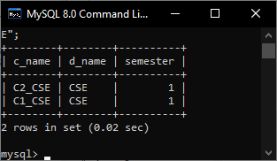

**d. Print the students roll no, Name and grades;**

SELECT s.rollno, s.name, e.grade

FROM student s

JOIN enrolls e

    USING (rollno)

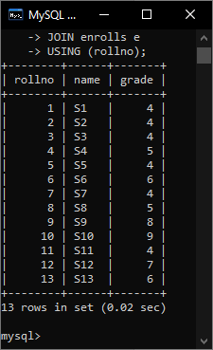

**e. Print the details of students who are enrolled for different courses.**

**Roll Name Course**

**1 A C1**

**2 B C1**

**3 C C2**

**4 D C2**

**5 E C3**